

Web Dev 1
Assessment 2: Web Development Project
Module Coordinator: J Ponte
Marker: J Ponte & Andy Gray

Date of submission: 05/06/2024
Number of words: 911 + 8min video/800 = 1,711

Brief:
Whilst working on this Web Development project, I decided on using “KnowYourCyber” client brief. I wanted the site to illustrate a database of cyber security threats that have the probability of happening, what they are about, and how we can avoid them or respond in case they happen correctly. The website comprises a landing page as well as a database and about pages.

Technical Breakdown:
Video Breakdown: Untitled video (1).mp4
The site contains four primary HTML files: index.html, landing.html, database.html and about.html. Its content and structure are crafted by these files. To maintain uniformity in all the pages, a conventional design based on a base template has been utilized in the HTML files.

Base Template (index.html)
This base template is just the nav bar.
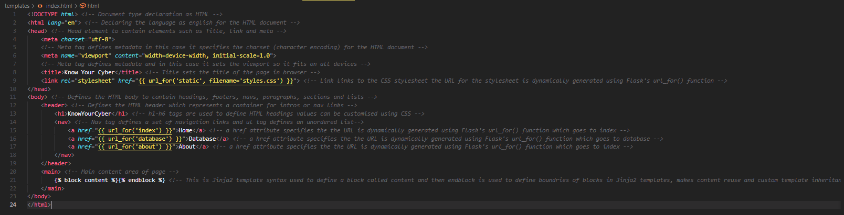

Landing Page (landing.html)
The landing page is the homepage of the website where it has placeholder text and a stock image from pexels.
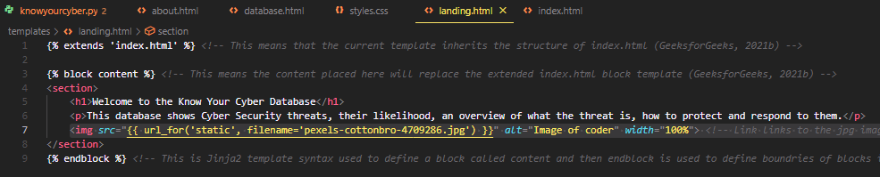
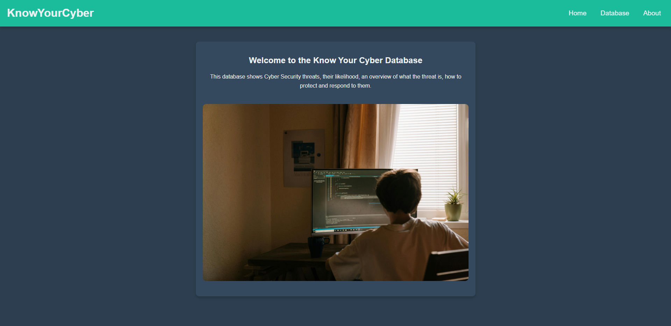

Database Page (database.html)
The database page displays the data in the format of the structure from the knowyourcyber database which is stored on a localhost SQL database.
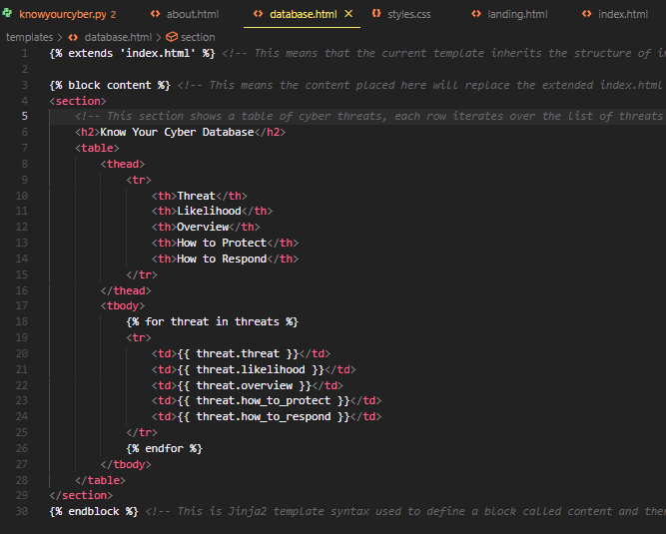
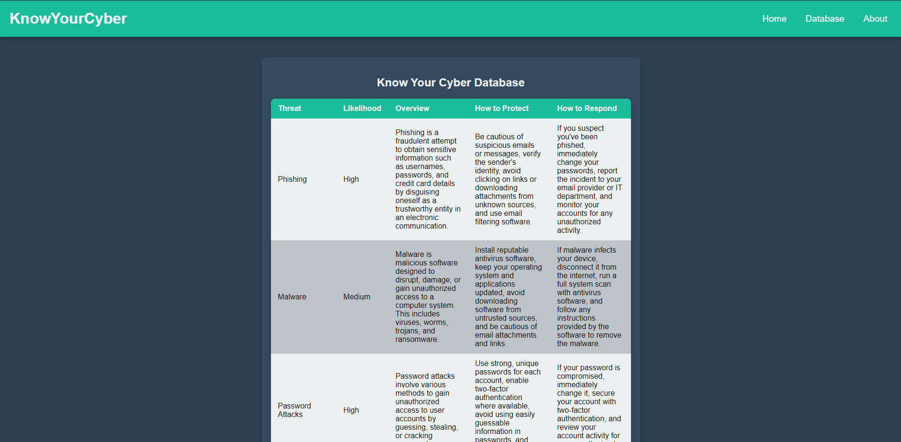

About page (about.html)
The about page shows place holder text and a stock image from pexels, is there to meet the requirement of the website having three pages.
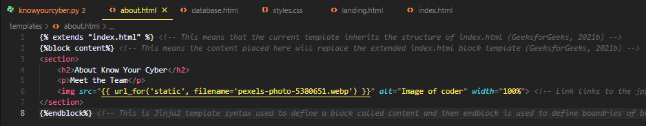
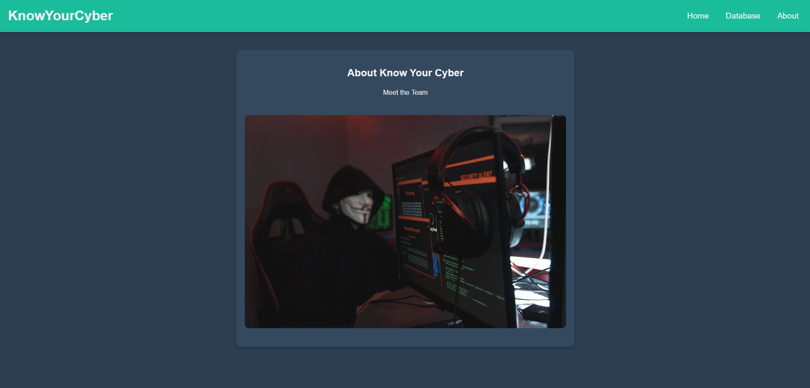

CSS Styling
Written in styles.css, the CSS file takes care of the website's visual presentation, guaranteeing a central layout that is appealing to the eyes, exactly. More emphasis was put on achieving a design that is both modern and uncluttered, especially when it came to the navigation bar and the database table. (Academy, 2024)

Python Flask Application
Flask is a useful python web framework that has useful tools and features for making web applications in Python. Flask uses the Jinja template engine to build HTML template pages. (Dyouri, 2020)
Since Flask is made in python you can import modules like mysql.connector to connect to MySQL databases, in this case the “knowyourcyberDb” function connects to the localhost SQL database and is used to execute SQL fetch data queries.
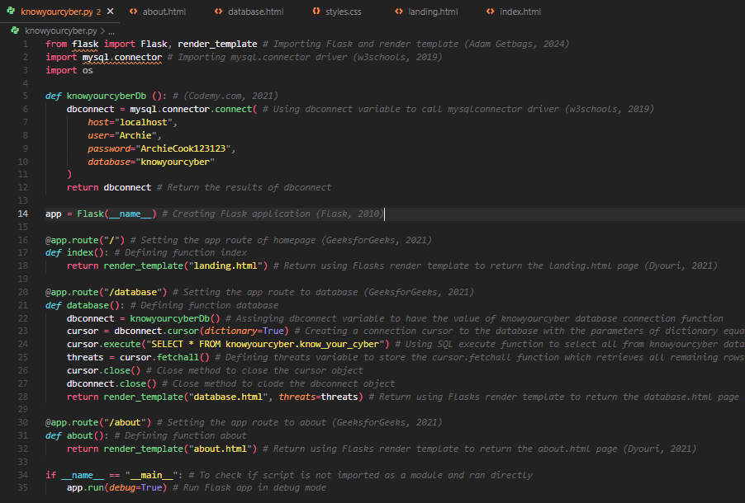
Flask routing is done by using “@app.route which maps the URLS to their respective functions and renders the HTML templates, these include “index”, “database”, “about”, and “landing”. (GeeksforGeeks, 2021a)

Additional Requirement:
I executed various design and programming tactics to make the website respond to the demands of the users in terms of visual design. For this project, the visual design must be modern and simple while the website must be fairly responsive.
Responsive Design:
For the layout, I used Flexbox to have the items in the center and align them well on all screens, no matter the size. It supports a flexible layout that responds to different viewport sizes hence a consistent user experience across devices. However, to be specific at other levels within the design of complex documents one might need to use media queries. However, I felt that for this particular application, we only needed a responsive layout therefore there was no need to include media queries. (Mozilla, 2019)
Visual Design: I have decided to create a current, uncluttered colour palette drawing inspiration from Material Design principles. It was a dark navy color (#2c3e50) selected as a background to perfectly match with the light text colour (#ecf0f1). To grab the user's attention an intense green color (#1abc9c) for headers is used, I went for a complementary colour scheme as I wanted the website to be simple yet also pop. (w3schools, 2024)
To achieve a clean visual design the use of box shadows and round corners on the body part create a sense of depth. To attain such effects properties like border-radius and box-shadow are used in the CSS. (Cope, 2011)
It is done using CSS with pseudo-classes such as nth-child(even) for alternating row colours within tables as well as hover that improves readability and gives visual feedback to website users. (w3schools, 2019a)
User experience: To make navigation easier and more intuitive, the navigation bar is at the top of the website. This makes it easier for users to find their way around with ease thereby improving the general user experience. To make it more readable, the content has consistent spacing, font sizes, and alignment in terms of its layout. (AIContentfy Team, 2023)

Critical Reflection:
This is a project which displays a website that is practical and appealing to the eye at the same time, and which meets the needs of the customer. But it could be enhanced in several different ways.
Interesting Features: A neat and stylish design that is eye candy and makes it interactively enjoyable. By going back to Flask on the server side, I have chosen sustainable ways of sending dynamic bits of data. Integration with databases makes it easier to manage and update cybersecurity in general.
Areas for Improvement: One area of improvement could be more responsiveness as shown in present form. User experience on mobile devices could be greatly enhanced through the addition of media queries as well as increased layout specificity over different screen sizes. (Mozilla, 2019)
Accessibility: It is critical that our site can be accessed by all regardless of their physical limitations while using computers or browsing online material hence enhancing adaptability inclusive of features like ARIA roles addition (Mozilla, 2024), better contrast between colours used as well as text alternative provision for graphics
Performance: Compressing images and using browser caching, could help enhance the site's overall user experience as well as decrease load times (LinkedIn, 2024) but since it is such a simple Flask web application it is pretty quick to load all data and images.

References:
Academy, T. (2024). How CSS Simplifies Web Development and Enhances User Experience. [online] Medium. Available at: https://medium.com/@-TutortAcademy/how-css-simplifies-web-development-and-enhances-user-experience-947bb2ad23e0 [Accessed 28 May 2024].
Adam Getbags (2024). Create A Flask Web App And Connect SQL Database - Python Tutorial. [online] YouTube. Available at: https://www.youtube.com/watch?v=MKG5BpZbOa4 [Accessed 27 May 2024].
AIContentfy Team (2023). Maximizing User Experience: Best Practices for Website Navigation. [online] AIContentfy. Available at: https://aicontentfy.com/en/blog/maximizing-user-experience-best-practices-for-website-navigation [Accessed 28 May 2024].
Codemy.com (2021). How To Use MySQL Database With Flask - Flask Fridays #9. YouTube. Available at: https://www.youtube.com/watch?v=hQl2wyJvK5k [Accessed 27 May 2024].
Cope, S. (2011). box-shadow. [online] CSS-Tricks. Available at: https://css-tricks.com/almanac/properties/b/box-shadow/ [Accessed 28 May 2024].
Dyouri, A. (2020). How To Make a Web Application Using Flask in Python 3. [online] DigitalOcean. Available at: https://www.digitalocean.com/community/tutorials/how-to-make-a-web-application-using-flask-in-python-3 [Accessed 28 May 2024].
Dyouri, A. (2021). How To Use Templates in a Flask Application | DigitalOcean. [online] www.digitalocean.com. Available at: https://www.digitalocean.com/community/tutorials/how-to-use-templates-in-a-flask-application [Accessed 27 May 2024].
Flask (2010a). Application Setup — Flask Documentation (3.0.x). [online] flask.palletsprojects.com. Available at: https://flask.palletsprojects.com/en/3.0.x/tutorial/factory/ [Accessed 27 May 2024].
Flask (2010b). Template Inheritance — Flask Documentation (2.3.x). [online] flask.palletsprojects.com. Available at: https://flask.palletsprojects.com/en/2.3.x/patterns/templateinheritance/ [Accessed 27 May 2024].
GeeksforGeeks (2021a). Flask App Routing. [online] GeeksforGeeks. Available at: https://www.geeksforgeeks.org/flask-app-routing/ [Accessed 27 May 2024].
GeeksforGeeks (2021b). Flask Rendering Templates. [online] GeeksforGeeks. Available at: https://www.geeksforgeeks.org/flask-rendering-templates/ [Accessed 27 May 2024].
Hevo (2023). Setting Up Flask MySQL Integration: 4 Easy Steps | Hevo. [online] Hevo. Available at: https://hevodata.com/learn/flask-mysql/ [Accessed 27 May 2024].
LinkedIn (2024). How do you leverage browser caching and compression to reduce page load time? [online] www.linkedin.com. Available at: https://www.linkedin.com/advice/0/how-do-you-leverage-browser-caching-compression [Accessed 28 May 2024].
Mozilla (2019). Responsive design. [online] MDN Web Docs. Available at: https://developer.mozilla.org/en-US/docs/Learn/CSS/CSS_layout/Responsive_Design [Accessed 28 May 2024].
Mozilla (2024). WAI-ARIA Roles - Accessibility | MDN. [online] developer.mozilla.org. Available at: https://developer.mozilla.org/en-US/docs/Web/Accessibility/ARIA/Roles [Accessed 28 May 2024].
stackoverflow (2019). Flask generate dynamic table where number of rows and columns depends on number of elements in the list. [online] Stack Overflow. Available at: https://stackoverflow.com/questions/57148521/flask-generate-dynamic-table-where-number-of-rows-and-columns-depends-on-number [Accessed 28 May 2024].
stackoverflow (2021). Python cursor.execute fetchall questions. [online] Stack Overflow. Available at: https://stackoverflow.com/questions/63758568/python-cursor-execute-fetchall-questions [Accessed 27 May 2024].
w3schools (2019a). CSS Pseudo-classes. [online] W3schools.com. Available at: https://www.w3schools.com/css/css_pseudo_classes.asp [Accessed 28 May 2024].
w3schools (2019b). Python MySQL. [online] W3schools.com. Available at: https://www.w3schools.com/python/python_mysql_getstarted.asp [Accessed 27 May 2024].
w3schools (2024). W3.CSS Color Schemes. [online] www.w3schools.com. Available at: https://www.w3schools.com/w3css/w3css_color_schemes.asp [Accessed 28 May 2024].

